# Apply filters to SQL queries

## Project description

[Describe what you accomplish through SQL.]

## Retrieve after hours failed login attempts

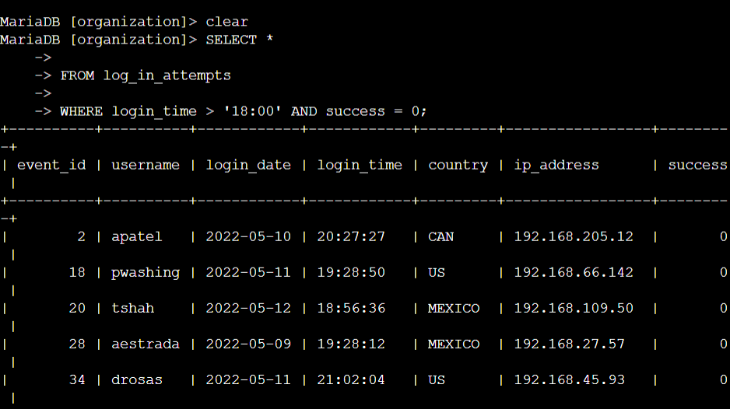

## Retrieve login attempts on specific dates

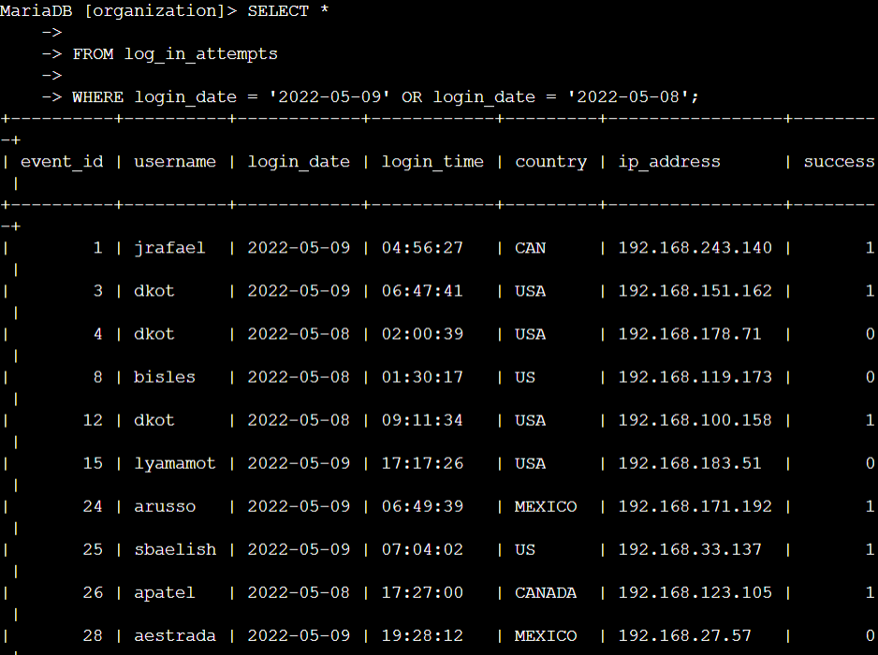

## Retrieve login attempts outside of Mexico

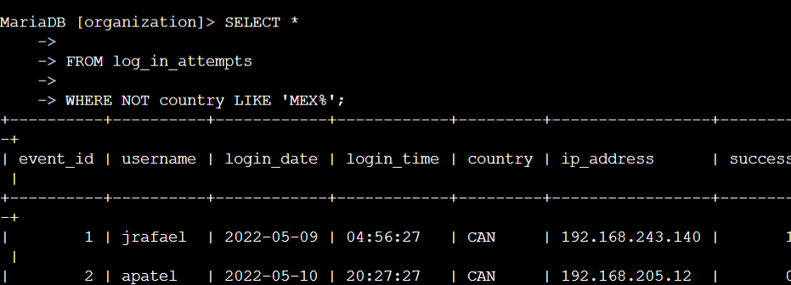

## Retrieve employees in Marketing

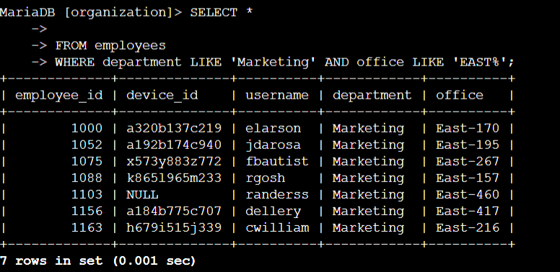

## Retrieve employees in Finance or Sales

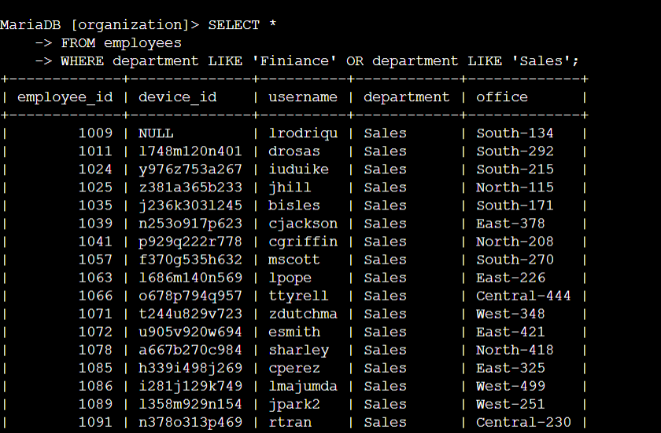

## Retrieve all employees not in IT

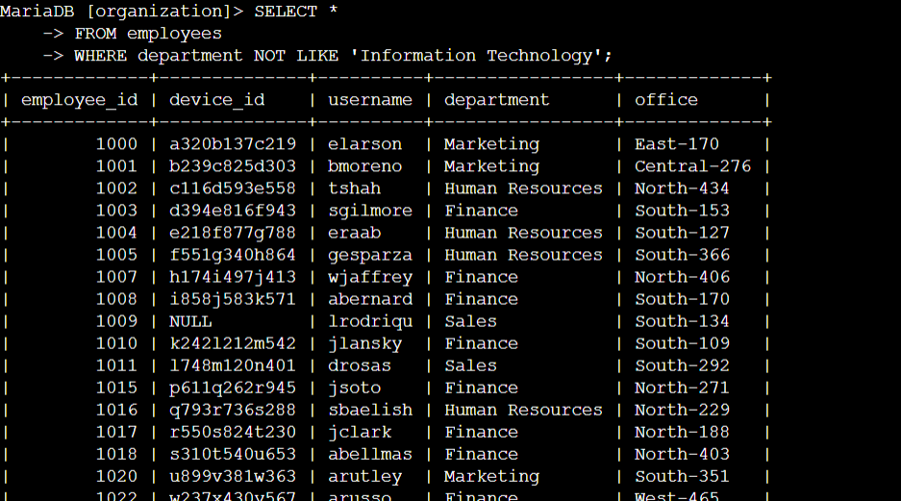

## Summary

[Add content here.]